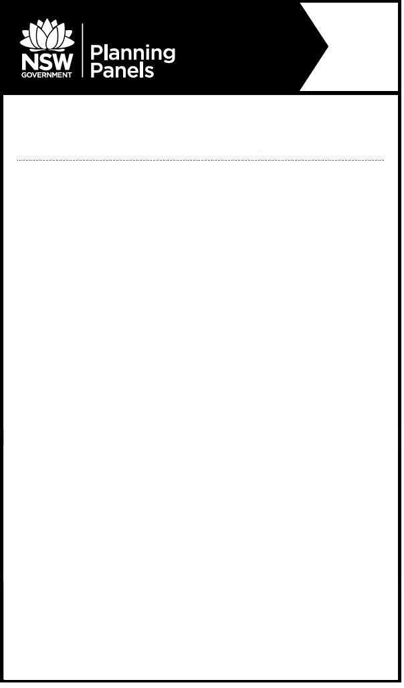

**Notice of Public Meeting**

**Sydney Central City**  **Planning Panel**

The panel will meet to determine the following:

* **PPSSCC-313 – The Hills - 859/2022/JP** - 55 Coonara Avenue, West Pennant Hills - Integrated Housing Development comprising the Torrens title subdivision and construction of 61 attached and detached dwellings
* **PPSSCC-314 – The Hills - 860/2022/JP** - 55 Coonara Avenue, West Pennant Hills - Concept Development Application for 418 dwellings, comprising 252 apartments and 166 dwelling houses including civil works comprising new roads, earthworks, stormwater and services infrastructure
* **PPSSCC-315 – The Hills - 861/2022/JP** - 55 Coonara Avenue, West Pennant Hills - Construction of Four Residential Flat Buildings containing a total of 252 Units and Basement Car Parking

**When:** Thursday, 27 October 2022 at 11:00am.

**Where:** The meeting will be held by public videoconference

Relevant documents will be available on the Planning Panels website [www.planningportal.nsw.gov.au/planningpanels](http://www.planningportal.nsw.gov.au/planningpanels) at least seven days before the meeting.

If you wish to either address the panel or to listen to this meeting, you must register by contacting the Planning Panels Secretariat before 4pm Tuesday, 25 October 2022 on 02 8217 2060 or via email to enquiry@planningpanels.nsw.gov.au.

On registration you will be provided the details to enable you to join the public videoconference for speakers and teleconference for listeners.

Please quote the reference numbers PPSSCC-313, PPSSCC-314, PPSSCC-315 in all communications.

The panel is required to make an audio record of the meeting and make the recording publicly available on the Planning Panels website. You should be aware that this may include your personal information if you are presenting to the panel.

**For more information:** (02) 8217 2060

www.planningportal.nsw.gov.au/planningpanels